Weather-Based Irrigation Dashboard

Overview
This project delivers a Weather-Based Irrigation Decision Dashboard built using Power BI, backed by a SQL Server database, and powered by a Python ETL pipeline. The system analyzes daily weather data — rainfall and evapotranspiration (ET₀) — to generate a clear irrigation recommendation: WATER or SKIP, along with the reason behind the decision.
The dashboard is designed for simplicity, transparency, and operational decision-making.
How to Run the Application
This project uses Power BI as the visualization layer. To run the full system:
1. Run the Python ETL Pipeline
Execute:
Code
python etl/etl_pipeline.py
This script:
- Extracts raw weather data
- Cleans and transforms it
- Loads it into SQL Server fact tables
4. Open the Dashboard
- Open Weather-Irrigation-Dashboard.pbix in Power BI Desktop
- Update the SQL Server connection string if needed
- Click Refresh
- Use the date slicer to explore irrigation decisions
All KPIs and visuals update dynamically.

Dependencies
Python Libraries
Code
pandas
requests
pyodbc
sqlalchemy
python-dotenv
Install with:
Code
pip install -r requirements.txt
Power BI
- Power BI Desktop
- SQL Server ODBC driver
Database
- SQL Server 2019+
- Tables:
  - FactDailyWeather
  - FactIrrigationDecision
  - DimDate
Dashboard Components
- Two KPI Cards
- WATER / SKIP — Today’s irrigation decision
- Reason — e.g., “Insufficient rain,” “Low ET₀,” etc.
These KPIs make the decision logic explicit and easy to understand.

- Two Visualizations
- Daily Rainfall Trend (mm)
- Line chart
- Shows rainfall patterns over time
- Helps explain the “Reason” KPI
- Daily ET₀ (Water Demand) and Rainfall
- Bars = ET₀
- Line = Rainfall
- Subtitle: “High ET₀ + Low Rain = Higher Irrigation Need”
- Shows how weather conditions drive irrigation decisions
- Interactive Filter
- Date slicer (between)
- Filters all visuals and KPIs dynamically
Screenshots
- Dashboard overview
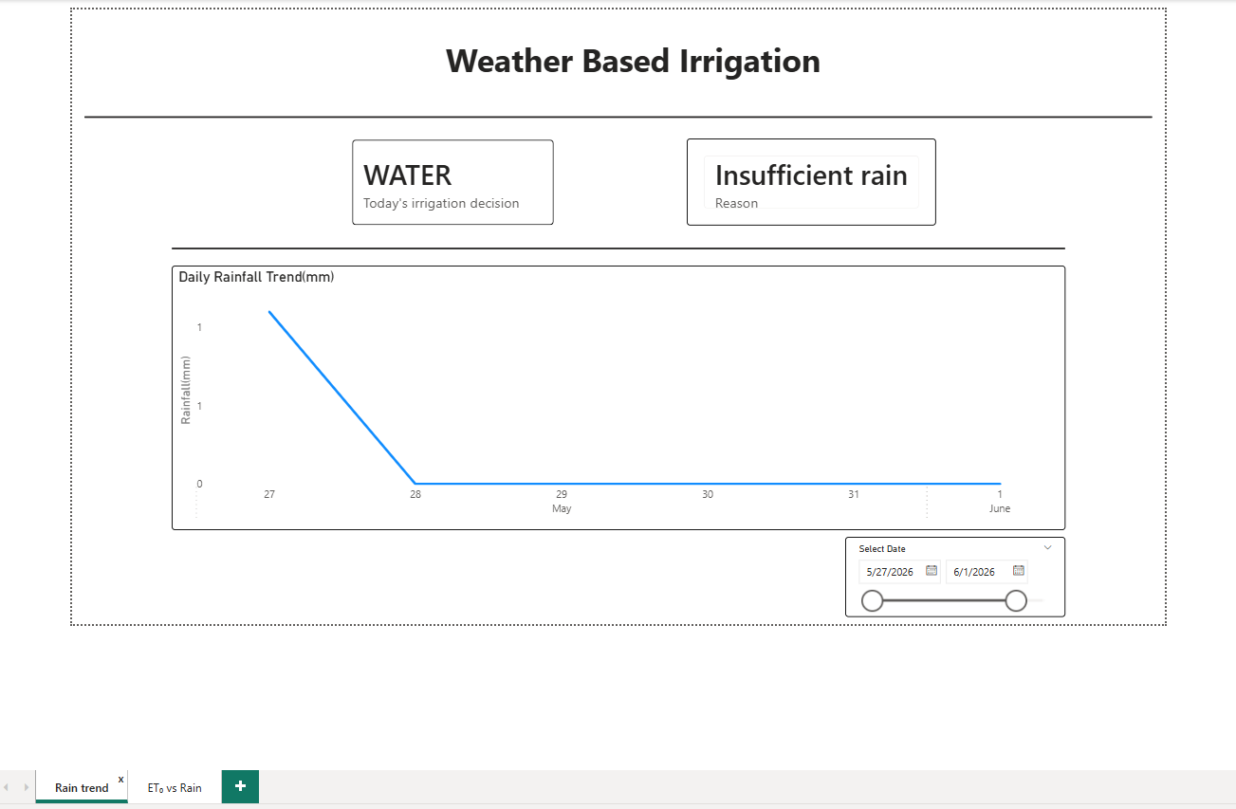
- Rainfall Trend
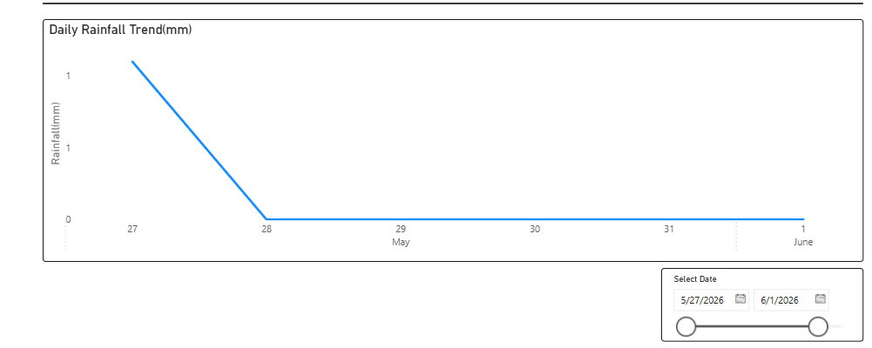
- Et0 vs rain
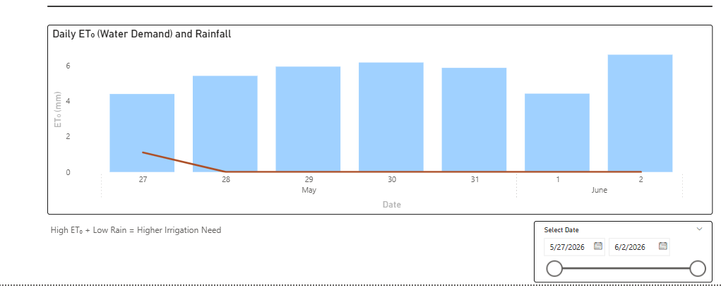
- Irrigation Kpi
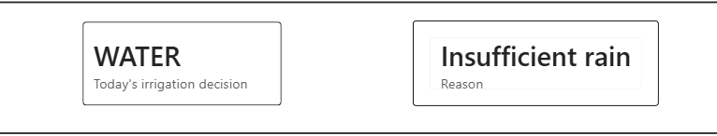

Business Insights
1. ET₀ Represents Water Demand
Evapotranspiration (ET₀) measures how much water plants lose to the atmosphere. Higher ET₀ → higher irrigation need.
2. Rainfall Reduces Irrigation Need
Rainfall replenishes soil moisture. Low rainfall + high ET₀ = WATER High rainfall + low ET₀ = SKIP
3. Transparent Decision Logic
The dashboard clearly explains:
- What the irrigation decision is
- Why the decision was made
The Reason KPI and the two charts work together to make the logic obvious.
4. Interactive Exploration
Users can explore:
- Weather patterns
- Water demand
- Irrigation decisions over time
This supports better planning and water conservation.

